A Project Report on

LIBRARY MANAGEMENT SYSTEM

Advanced Software Engineering & Development Internship

Submitted by

IN26012997 – Saubhagya Khare

Batch Code- 11A

in partial fulfillment of the requirements for the degree of Bachelor of Technology



VIT Bhopal University
Sehore - 466001
Madhya Pradesh

July, 2026

Project Link (Github): https://github.com/Saubhagya-23bce10357/Library-Management-System.git

Certificate

This is to certify that the following student has successfully & satisfactorily completed the project work "LIBRARY MANAGEMENT SYSTEM" presented their report in the partial fulfilment of the requirements for “Advanced Software Engineering & Development Internship" in MPOnline Internship and Certification Program, Bhopal.

YEAR 2026–27

Name | Enrolment No.
SAUBHAGYA KHARE | IN26012997

Supervisor

Sulakshana Deore
Preface

The Library Management System is developed as a part of the academic curriculum to apply theoretical knowledge to a practical software development project. The primary objective of this project is to design and develop a web-based application that automates the daily activities of a library, making the management of books, members, and transactions more efficient, accurate, and user-friendly.

This project has offered an excellent opportunity to understand the complete software development life cycle (SDLC), including requirement analysis, system design, database development, implementation, testing, and deployment.

It has also enhanced practical knowledge of object-oriented programming, web application development, database management, and software engineering principles.

The report presents the complete development process of the Library Management System, including system requirements, design methodology, implementation details, testing procedures, and future scope. Every effort has been made to ensure that the information provided in this report is accurate, systematic, and useful for understanding the development of the application.

It is hoped that this project will serve as a valuable reference for students, developers, and anyone interested in learning about web application development using C# and ASP.NET. The knowledge and experience gained during the development of this project will be beneficial for future academic work as well as professional software development.

Acknowledgement

I would like to express my sincere gratitude to everyone who supported me in the successful completion of my project titled "Library Management System Using C# and ASP.NET."

First and foremost, I am deeply thankful to my project guide and faculty members for their valuable guidance, encouragement, and constructive suggestions throughout the development of this project. Their expertise and continuous support helped me overcome various challenges and complete the project successfully.

I would also like to thank the Head of the Department and all the faculty members for providing the necessary resources, facilities, and a conducive learning environment that made this project possible.

I extend my heartfelt appreciation to my friends and classmates for their cooperation, technical assistance, and valuable feedback during the various stages of project development.

Finally, I am grateful to my parents and family members for their constant encouragement, motivation, and unwavering support throughout this project.

Abstract
The Library Management System is a web-based application developed using C#, ASP.NET, Entity Framework, SQL Server, HTML, CSS, JavaScript, and Bootstrap to automate and simplify the day-to-day operations of a library. The system replaces the traditional manual method of managing library records with a secure, efficient, and user-friendly digital platform.
The application enables administrators to manage books, categories, authors, publishers, students, and library staff through a centralized dashboard. It provides features such as adding, updating, deleting, and searching book records, issuing and returning books, tracking due dates, calculating fines (if applicable), and maintaining complete borrowing history. The system also supports user authentication and role-based access to ensure data security and prevent unauthorized access.
By maintaining all library information in a centralized database, the system minimizes paperwork, reduces human errors, and improves the speed and accuracy of library operations. The search functionality allows users to quickly locate books, while automated record management enhances efficiency and saves time for both librarians and students.
The project follows a modular architecture that makes it scalable, maintainable, and easy to enhance with additional features such as barcode integration, email notifications, online book reservation, and report generation. During the development of this project, software engineering principles, database management techniques, and web development technologies were applied to build a reliable and responsive application.
In conclusion, the Library Management System provides an effective and practical solution for modern library management by improving operational efficiency, ensuring accurate record maintenance, and delivering a better user experience. The project demonstrates the practical implementation of C# and ASP.NET in developing a real-world web application that meets the requirements of educational institutions and libraries.

Index
Chapter No. | Title | Page No.
 | Certificate | i
 | Declaration | ii
 | Acknowledgement | iii
 | Abstract | iv
 | Table of Contents | v

CHAPTER 1 – INTRODUCTION
Section | Title | Page No.
1.1 | Introduction | 1
1.2 | Objectives | 3
1.3 | Report Organization | 5

CHAPTER 2 – LITERATURE SURVEY
Section | Title | Page No.
2.1 | History of Library Management Systems | 6
2.2 | Need for Automation | 8
2.3 | Role of C# and ASP.NET | 10
2.4 | Existing Systems | 12
2.5 | Database Management Systems | 14

CHAPTER 3 – LIBRARY MANAGEMENT SYSTEM USING C# AND ASP.NET
Section | Title | Page No.
3.1 | Project Overview | 16
3.2 | Development Environment | 18
3.3 | Software & Hardware Requirements | 20
3.4 | Technologies Used | 22
3.5 | System Modules | 26
3.6 | Database Design | 30
3.7 | System Workflow | 33

CHAPTER 4 – IMPLEMENTATION AND RESULTS
Section | Title | Page No.
4.1 | System Implementation | 35
4.2 | Database Connectivity | 40
4.3 | System Testing | 42
4.4 | Test Cases | 45
4.5 | Results and Discussion | 48

CHAPTER 5 – CONCLUSION AND FUTURE SCOPE
Section | Title | Page No.
5.1 | Output | 50
5.2 | Future Scope | 52

References link (Github) | https://github.com/Saubhagya-23bce10357/Library-Management-System.git

CHAPTER 1

1.1 Introduction
The Libraries are one of the most important resources in educational institutions, providing students and faculty with access to books, journals, magazines, and other learning materials. Traditionally, libraries have relied on manual methods for maintaining records of books, members, book issues, and returns. As the number of books and users increases, manual management becomes time-consuming, inefficient, and prone to errors.
The Library Management System is a web-based application developed using C#, ASP.NET, SQL Server, Entity Framework, HTML, CSS, JavaScript, and Bootstrap. It automates all library activities and provides an efficient platform for managing books, students, authors, categories, book issues, and returns.
The system enables librarians to maintain complete records digitally, reducing paperwork and improving the accuracy of library operations. Users can easily search for books, while administrators can manage the entire library through a secure login system.
The application follows modern software development practices and provides a user-friendly interface that makes library management simple and efficient. The use of a centralized database ensures data consistency, reduces duplication, and improves overall system performance.

1.2 Motivation
The primary motivation behind developing the Library Management System using C# and ASP.NET is to replace the traditional manual library management process with a secure, efficient, and user-friendly digital solution. Manual record keeping is time-consuming, prone to errors, and difficult to maintain as the number of books and library members increases.
This project aims to simplify library operations such as book management, member registration, book issue and return, and record maintenance through automation. By using modern web technologies like C#, ASP.NET, Entity Framework, and SQL Server, the system improves accuracy, reduces paperwork, and enhances the overall efficiency of library management.
The project also provides practical experience in web application development, database management, and software engineering concepts while demonstrating how technology can be used to solve real-world problems in educational institutions.

1.3 Objective
The main objective of the Library Management System using C# and ASP.NET is to develop a secure, efficient, and user-friendly web application that automates the daily operations of a library. The system is designed to simplify the management of books, authors, categories, students, and book transactions by replacing manual record-keeping with a computerized solution.
It aims to reduce paperwork, minimize human errors, and improve the speed and accuracy of library operations. The application enables administrators to easily add, update, delete, and search book records while maintaining complete information about issued and returned books.
It also provides secure user authentication and centralized database management using SQL Server to ensure data integrity and reliability.
Furthermore, the project aims to enhance the overall efficiency of library services, provide quick access to information, generate useful reports, and offer practical experience in developing real-world web applications using C#, ASP.NET, Entity Framework, and SQL Server.
The main objectives of the project are:
- To automate the daily activities of the library.
- To maintain digital records of books and members.
- To simplify book issue and return operations.
- To reduce manual paperwork and human errors.
- To provide secure authentication for administrators.
- To improve the speed and accuracy of searching books.
- To generate reports efficiently.
- To maintain complete borrowing history.

1.4 Report Organization
This project report is organized into different chapters to explain the development process of the Library Management System in a systematic manner.
Chapter 1 introduces the project, explains its objectives, and provides an overview of the report.
Chapter 2 presents the literature survey, discussing the history of library management systems, the need for automation, related technologies, and previous research.
Chapter 3 describes the technologies used in developing the project, including C#, ASP.NET, SQL Server, Bootstrap, and Visual Studio.
Chapter 4 explains the implementation of the project, database design, system modules, testing, and output screenshots.
Chapter 5 concludes the report by summarizing the achievements, limitations, and future scope of the project.
Finally, the report includes references used during the development of the project.

CHAPTER 2

LITERATURE SURVEY

2.1 History of Library Management Systems
Libraries have been an important source of knowledge for centuries. Initially, books were cataloged manually using paper records and card catalog systems. As the number of books increased, managing library records became increasingly difficult.
With the introduction of computers in the 1970s and 1980s, libraries began adopting computerized management systems. Early systems focused mainly on catalog management and inventory tracking. Later, integrated library management systems were developed, providing features such as book circulation, membership management, report generation, and online catalog searching.
Modern library systems use web technologies and cloud computing to provide remote access, digital libraries, and real-time database management. These systems have significantly improved the efficiency, reliability, and accessibility of library services.

2.2 Need for Automation in Library Management
Manual library management suffers from several limitations, including slow processing, human errors, difficulty in maintaining records, and inefficient searching of books.
Automation addresses these challenges by providing:
- Fast access to book information.
- Efficient book issue and return process.
- Automatic fine calculation.
- Secure storage of records.
- Easy report generation.
- Improved inventory management.
- Better user experience.
- Reduced paperwork.
- Real-time database updates.
- Improved data security.
Automation also reduces operational costs and increases the productivity of library staff.

2.3 Role of C# and ASP.NET in Library Management
C# is a powerful object-oriented programming language developed by Microsoft for building secure and scalable applications. ASP.NET is Microsoft's web application framework that allows developers to build dynamic web applications efficiently.
The combination of C# and ASP.NET provides:
- High performance
- Strong security features
- Easy database connectivity
- Session management
- Authentication and authorization
- Reusable code architecture
- MVC support
- Responsive web application development
These technologies are ideal for developing enterprise-level applications such as library management systems.

2.4 Review of Existing Library Management Systems
Several commercial and open-source library management systems are available today. Popular examples include Koha, Evergreen, NewGenLib, and SLiMS.
These systems provide features such as:
- Book catalog management
- Member registration
- Barcode support
- Report generation
- Fine management
- Online Public Access Catalog (OPAC)
Although these systems are highly capable, many institutions require customized solutions based on their specific requirements. Therefore, developing a custom Library Management System allows flexibility, easier maintenance, and institution-specific customization.

2.5 Review of Database Management Systems
A Database Management System (DBMS) is essential for storing, retrieving, updating, and managing data efficiently.
For this project, Microsoft SQL Server is used because it offers:
- High reliability
- Strong security
- Efficient query processing
- Backup and recovery
- Transaction management
- Scalability
- Easy integration with ASP.NET
SQL Server stores information related to books, users, issued books, returned books, fines, and library transactions.

CHAPTER 3

LIBRARY MANAGEMENT SYSTEM (C# & ASP.NET)

3.1 Overview of the Project
The Library Management System is a web-based application designed to automate and simplify the day-to-day operations of a library. The system has been developed using C# programming language and ASP.NET framework with Microsoft SQL Server as the backend database. The main purpose of the project is to replace the traditional manual library management process with an efficient, secure, and computerized system.
In many educational institutions, library records are still maintained manually, making it difficult to manage large collections of books and student information. Manual methods consume considerable time, increase paperwork, and often lead to errors in maintaining records. The proposed system addresses these problems by providing a centralized platform where librarians can manage books, students, transactions, and reports with ease.
The application provides separate interfaces for administrators and students. The administrator has complete control over the library database, including adding new books, updating existing records, managing authors and categories, issuing and returning books, calculating fines, and generating reports. Students can log into the system to search for books, view book availability, check issued books, and manage their profiles.
The project follows a modular approach, where each module performs a specific function independently while interacting seamlessly with other modules. This modular design improves maintainability and allows future enhancements without affecting the existing functionality.
The Library Management System also improves security by implementing user authentication and authorization mechanisms. Sensitive information is stored securely in the SQL Server database, and only authenticated users can access administrative functions.
Overall, the system provides an efficient, reliable, user-friendly, and scalable solution that reduces manual work, increases operational efficiency, and enhances the overall experience of both librarians and students.

3.2 Development Environment
The Library Management System has been developed using Microsoft's latest web development technologies. The development environment provides all the necessary tools for designing, coding, testing, debugging, and deploying the application.
The primary software used for developing the project includes:
- Microsoft Visual Studio 2022
- ASP.NET Framework
- C# Programming Language
- Microsoft SQL Server
- SQL Server Management Studio (SSMS)
- HTML5
- CSS3
- Bootstrap Framework
- JavaScript
- IIS Express
Visual Studio provides an integrated development environment (IDE) that simplifies application development through intelligent code completion, debugging tools, project management, and integrated database connectivity.
ASP.NET provides a powerful framework for creating dynamic web applications, while SQL Server ensures efficient storage and retrieval of library records.
Bootstrap has been used to create a responsive interface that automatically adjusts to desktops, laptops, tablets, and mobile devices.

3.3 Software Requirements
The following software components are required for the successful execution of the Library Management System.
Software | Specification
Operating System | Windows 10/11
IDE | Microsoft Visual Studio 2022
Framework | ASP.NET
Programming Language | C#
Database | Microsoft SQL Server
Database Tool | SQL Server Management Studio
Browser | Google Chrome / Microsoft Edge
Front-End | HTML, CSS, Bootstrap, JavaScript
These software components work together to provide a complete development and execution environment for the applications.
3.4 Hardware Requirements
The hardware configuration required to develop and execute the project is relatively modest.
Component | Minimum Requirement
Processor | Intel Core i3 or Higher
RAM | 8 GB
Storage | 256 GB SSD
Display | 1366 × 768 Resolution
Keyboard | Standard Keyboard
Mouse | Optical Mouse
Internet | Required for Updates
The application can also run smoothly on systems with higher configurations, providing faster response time and better performance.

3.5 Technologies Used
Several modern technologies have been integrated into the development of the Library Management System.

C#
C# is an object-oriented programming language developed by Microsoft. It provides powerful features such as classes, inheritance, polymorphism, exception handling, and database connectivity. C# serves as the core programming language for implementing the business logic of the application.
Advantages of C# include:
- Easy to learn and maintain
- Strong type checking
- High security
- Excellent database support
- Rich class libraries
- Platform compatibility

ASP.NET
ASP.NET is Microsoft's web application development framework that enables developers to build dynamic and interactive web applications.
The framework offers several benefits:
- High performance
- Secure authentication
- Session management
- Easy deployment
- MVC architecture support
- Built-in validation controls
ASP.NET handles the interaction between the user interface and the backend database efficiently.

Microsoft SQL Server
Microsoft SQL Server is a relational database management system used to store all application data.
It maintains information such as:
- Student Details
- Book Details
- Author Information
- Categories
- Issue Records
- Return Records
- Fine Details
- Login Credentials
SQL Server ensures data integrity, fast query execution, secure storage, and backup facilities.

HTML
HTML (HyperText Markup Language) is used for creating the structure of web pages. Every page of the Library Management System is built using HTML elements such as forms, tables, buttons, images, and navigation menus.
CSS
CSS (Cascading Style Sheets) is used for designing attractive user interfaces. It controls colors, fonts, layouts, spacing, animations, and responsiveness of the web pages.

Bootstrap
Bootstrap is a front-end framework used to create responsive web pages quickly.
Its advantages include:
- Mobile-friendly interface
- Pre-designed components
- Responsive grid system
- Faster UI development
- Professional appearance

JavaScript
JavaScript is used to improve user interaction by performing client-side validation, displaying dynamic content, handling events, and enhancing the overall user experience.

3.6 System Modules
The Library Management System is divided into several modules that work together to perform library operations efficiently.

3.6.1 Administrator Module
The Administrator Module is the central part of the application. It provides complete control over all library operations.
The administrator can perform the following tasks:
- Login securely
- Add new books
- Update book information
- Delete books
- Manage book categories
- Manage authors
- Register students
- Edit student information
- Issue books
- Receive returned books
- Calculate overdue fines
- Generate reports
- Monitor overall library activities
The administrator dashboard displays important statistics such as total books, issued books, returned books, registered students, and overdue books.
3.6.2 Student Module
The Student Module enables students to access library services online.
Students can:
- Register themselves
- Login securely
- Search books
- View available books
- View issued books
- Check due dates
- View borrowing history
- Update personal information
The student interface is simple, responsive, and easy to navigate.

3.6.3 Book Management Module
This module manages all information related to books.
Functions include:
- Add new books
- Update book details
- Delete books
- Search books
- View book availability
- Manage ISBN numbers
- Maintain quantity of books
- Assign categories
This module ensures that all books are properly organized and easy to locate.

3.6.4 Issue and Return Module
The Issue and Return Module automates the complete borrowing process.
Major functions include:
- Issue books
- Return books
- Verify student eligibility
- Update stock automatically
- Calculate return date
- Generate overdue fine
- Maintain transaction history
This module reduces manual calculations and ensures accurate tracking of every issued book.

3.6.5 Report Module
The Report Module generates various reports required by the library administration.
Available reports include:
- Available Books Report
- Issued Books Report
- Returned Books Report
- Student Report
- Fine Report
- Category Report
- Author Report
- Daily Transaction Report
These reports help the librarian monitor library activities and make informed decisions.

3.7 Database Design
The Library Management System uses Microsoft SQL Server as its backend database. The database is designed following the principles of normalization to eliminate redundancy and maintain consistency.
The major tables included in the database are:

Admin Table
Stores administrator login details.
Fields:
- AdminID
- Username
- Password
- Email

Student Table
Stores student information.
Fields:
- StudentID
- Student Name
- Department
- Email
- Mobile Number
- Password

Book Table
Stores complete information about books.
Fields:
- BookID
- Book Name
- ISBN
- AuthorID
- CategoryID
- Publisher
- Quantity
- Available Copies

Author Table
Contains details of book authors.

Category Table
Stores different categories of books.
Examples:
- Computer Science
- Electronics
- Mechanical
- Civil
- Management
- Literature

Issue Book Table
Stores issued book records.
Fields include:
- IssueID
- StudentID
- BookID
- Issue Date
- Due Date
- Return Date
- Fine Amount

3.8 System Workflow
The overall workflow of the application is as follows:
- The administrator logs into the system.
- Books, categories, and authors are added to the database.
- Students register and log into the application.
- Students search for available books.
- The administrator issues books to eligible students.
- The system updates the available quantity automatically.
- Students return books before or after the due date.
- The system calculates overdue fines automatically.
- Reports are generated for administrative purposes.
This workflow ensures smooth and efficient management of all library activities.

3.9 Advantages of the Proposed System
The proposed Library Management System offers numerous advantages over the traditional manual system:
- Reduces paperwork and manual effort.
- Improves accuracy in maintaining records.
- Provides faster book searching.
- Enables secure user authentication.
- Automates issue and return transactions.
- Calculates overdue fines automatically.
- Generates reports instantly.

CHAPTER 4

IMPLEMENTATION AND RESULTS

4.1 System Implementation
The implementation phase is one of the most important stages in the development of the Library Management System. During this phase, all the planning, analysis, and design developed in the previous stages are converted into a fully functional web application. The project has been implemented using C# as the programming language, ASP.NET as the web development framework, and Microsoft SQL Server as the backend database. The development environment used for the project is Microsoft Visual Studio 2022, which provides powerful tools for coding, debugging, testing, and deployment.
The implementation process begins with the creation of the database, where all the necessary tables are designed to store information related to books, students, administrators, authors, categories, and book transactions. Proper relationships are established between the tables using primary keys and foreign keys to maintain data integrity and eliminate redundancy.
After designing the database, the frontend of the application is developed using HTML5, CSS3, Bootstrap, and JavaScript. Bootstrap is used to create a responsive user interface that works efficiently on desktops, laptops, tablets, and mobile devices. CSS is used to improve the appearance of the application by designing attractive forms, navigation bars, buttons, tables, and dashboards. JavaScript is implemented for client-side validation and interactive features, reducing unnecessary communication with the server.
The backend is developed using ASP.NET with C#, which handles all the business logic of the application. The backend communicates with the SQL Server database to perform operations such as inserting new records, updating existing data, deleting records, searching books, issuing books, returning books, and generating reports. The application follows a modular structure, making it easier to maintain, debug, and enhance in the future.
The administrator is required to log into the system using a valid username and password. Authentication ensures that only authorized users can access sensitive features such as adding books, editing student details, issuing books, and viewing reports. Students also have separate login credentials, allowing them to search books, view their borrowing history, and manage their personal information securely.
The overall implementation process is divided into different modules, each performing a specific function within the Library Management System.

4.1.1 Administrator Login Module
The Administrator Login Module provides secure authentication for the librarian or system administrator. Before accessing the dashboard, the administrator must enter a valid username and password. The entered credentials are verified against the SQL Server database.
After successful login, the administrator is redirected to the dashboard, where various management options are available. If incorrect credentials are entered, an appropriate error message is displayed, preventing unauthorized access.
The administrator dashboard provides quick access to all important modules such as book management, student management, issue and return operations, report generation, and system settings.

4.1.2 Book Management Module
The Book Management Module is responsible for maintaining complete information about books available in the library. This module allows the administrator to add new books, edit existing records, delete books, and search for books based on different criteria.
While adding a new book, the administrator enters details such as the book title, author name, ISBN number, publisher, category, quantity, and shelf location. The entered information is validated before being stored in the database.
The search functionality enables quick retrieval of books using keywords such as book title, author, category, or ISBN number. Whenever a book is issued or returned, the available quantity is automatically updated.

4.1.3 Student Management Module
The Student Management Module stores complete information about registered library members. The administrator can add new students, edit their information, delete inactive accounts, and search student records.
The system stores important information including:
- Student ID
- Student Name
- Department
- Email Address
- Mobile Number
- Registration Date
- Login Credentials
This module helps maintain an organized database of all library users.

4.1.4 Author and Category Module
Books are classified according to their respective authors and categories. Before adding books to the system, the administrator creates categories such as Computer Science, Electronics, Mathematics, Literature, History, and Management.
Similarly, author details are stored separately to avoid duplication and improve database normalization.
This module simplifies searching and filtering books based on author names or subject categories.

4.1.5 Book Issue Module
The Book Issue Module automates the process of lending books to students. The administrator selects the student and the desired book from the database. Before issuing the book, the system checks whether copies are available.
If the book is available, the system records the issue date, calculates the due date, and updates the available quantity of books automatically.
Each transaction is stored permanently in the database for future reference.

4.1.6 Book Return Module
The Book Return Module manages the return process efficiently. When a student returns a borrowed book, the administrator enters the return details into the system.
The application compares the return date with the due date. If the book is returned after the due date, the system automatically calculates the overdue fine based on predefined rules.
The available quantity of the returned book is updated immediately, ensuring accurate inventory management.

4.1.7 Search Module
One of the most useful features of the Library Management System is the advanced search functionality. Users can quickly locate books by entering keywords.
The system supports searching based on:
- Book Name
- Author Name
- ISBN Number
- Category
- Publisher
This significantly reduces the time required to locate books compared to manual searching.

4.1.8 Report Generation Module
The Report Generation Module provides useful reports for library administrators. Reports help monitor daily activities and assist in decision-making.
The system generates reports such as:
- Total Books Report
- Issued Books Report
- Returned Books Report
- Available Books Report
- Student Report
- Fine Collection Report
- Category-wise Book Report
- Monthly Transaction Report
These reports can be viewed on-screen and printed whenever required.

4.2 Database Connectivity
Database connectivity is established between the ASP.NET application and Microsoft SQL Server using secure connection strings. The application performs all database operations through SQL queries or Entity Framework.
The following database operations are performed:
- Insert new records
- Retrieve records
- Update existing information
- Delete unnecessary records
- Search records
- Generate reports
Proper exception handling ensures smooth communication between the application and the database.

4.3 System Testing
Testing is an important phase that ensures the Library Management System functions correctly without errors. Different testing techniques are applied to verify the reliability, efficiency, and security of the application.
The major testing methods include:

Unit Testing
Each module, such as Login, Book Management, Student Management, and Book Issue, is tested individually to verify that it performs its intended function correctly.

Integration Testing
Integration testing verifies that different modules communicate correctly with one another. For example, when a book is issued, the available quantity in the Book Management Module should update automatically.

System Testing
The complete application is tested under different scenarios to ensure that all modules work together as expected.

User Acceptance Testing
The application is tested by potential users, including librarians and students, to verify that the software satisfies user requirements and provides a user-friendly experience.

4.4 Test Cases
Test Case | Input | Expected Result | Actual Result | Status
Administrator Login | Valid Username & Password | Login Successful | Successful | Pass
Student Login | Valid Credentials | Login Successful | Successful | Pass
Add Book | Valid Book Details | Book Added Successfully | Successful | Pass
Update Book | Modified Details | Book Updated | Successful | Pass
Delete Book | Book ID | Book Deleted | Successful | Pass
Search Book | Book Name | Book Displayed | Successful | Pass
Issue Book | Student ID & Book ID | Book Issued | Successful | Pass
Return Book | Book ID | Book Returned | Successful | Pass
Fine Calculation | Late Return | Fine Generated | Successful | Pass

4.5 Output Screens
The Library Management System provides several interactive screens during execution. The important output screens include:
- Home Page
- Administrator Login Page
- Student Registration Page
- Student Login Page
- Dashboard
- Add Book Page
- Manage Books Page
- Manage Students Page
- Issue Book Page
- Return Book Page
- Book Search Page
- Reports Page
Each screen is designed with a simple, responsive, and user-friendly interface to ensure easy navigation and efficient operation.

4.6 Results and Discussion
The Library Management System was successfully implemented and tested using Visual Studio and SQL Server. The system performed all major library operations accurately and efficiently. The administrator was able to manage books, students, categories, and transactions without any difficulties. Students could search for books, view availability, and access their borrowing history through a secure login.
The application significantly reduced manual work, improved record accuracy, and minimized the possibility of human error. Automatic updating of book quantities, fine calculation, and report generation enhanced the efficiency of library operations. The use of a relational database ensured data consistency, while the responsive web interface provided a smooth user experience across different devices.
Overall, the developed system achieved all the objectives defined at the beginning of the project. It offers a reliable, scalable, and user-friendly solution for managing library resources in educational institutions. The modular architecture also allows future enhancements, making the system adaptable to changing requirements and technological advancements.

CHAPTER 5

OUTPUT

5.1 Screenshots & Implementations
- Running Code
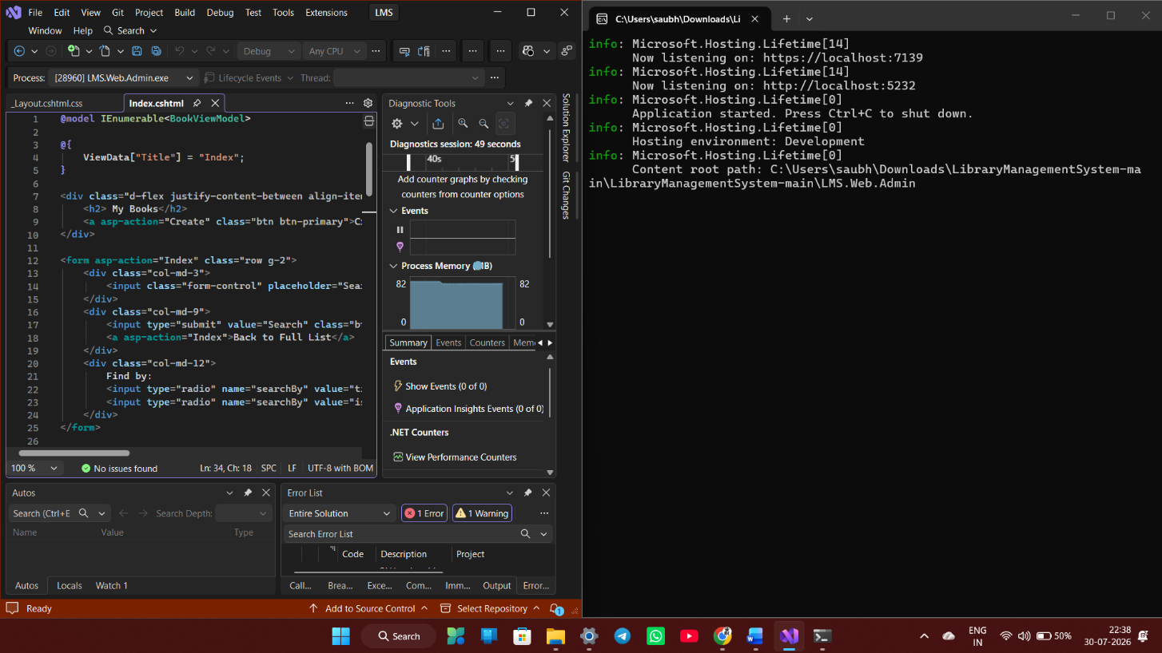
- Home Page
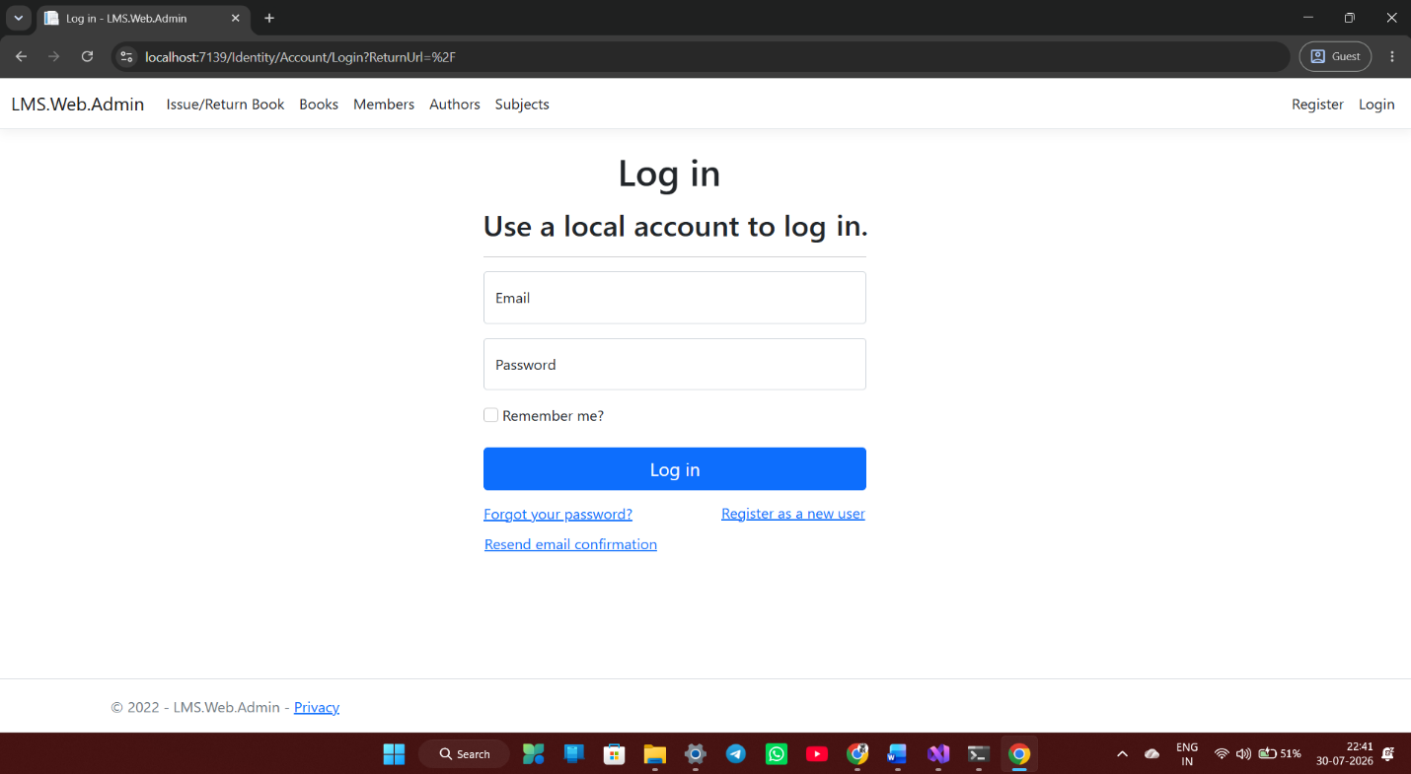
- Administrator Login Page
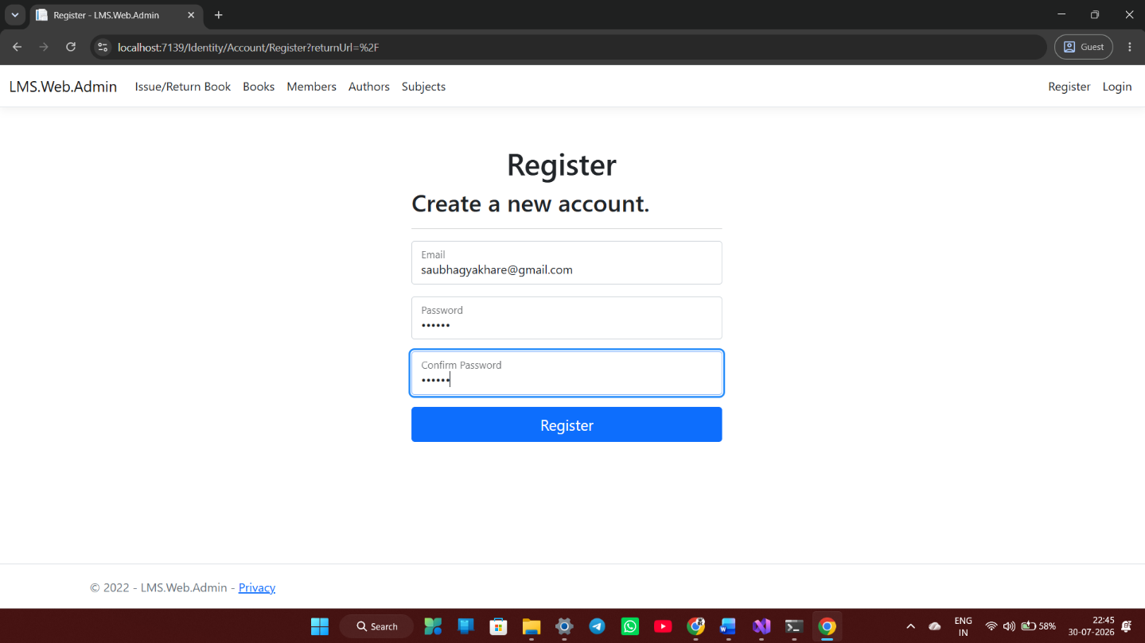
- Dashboard
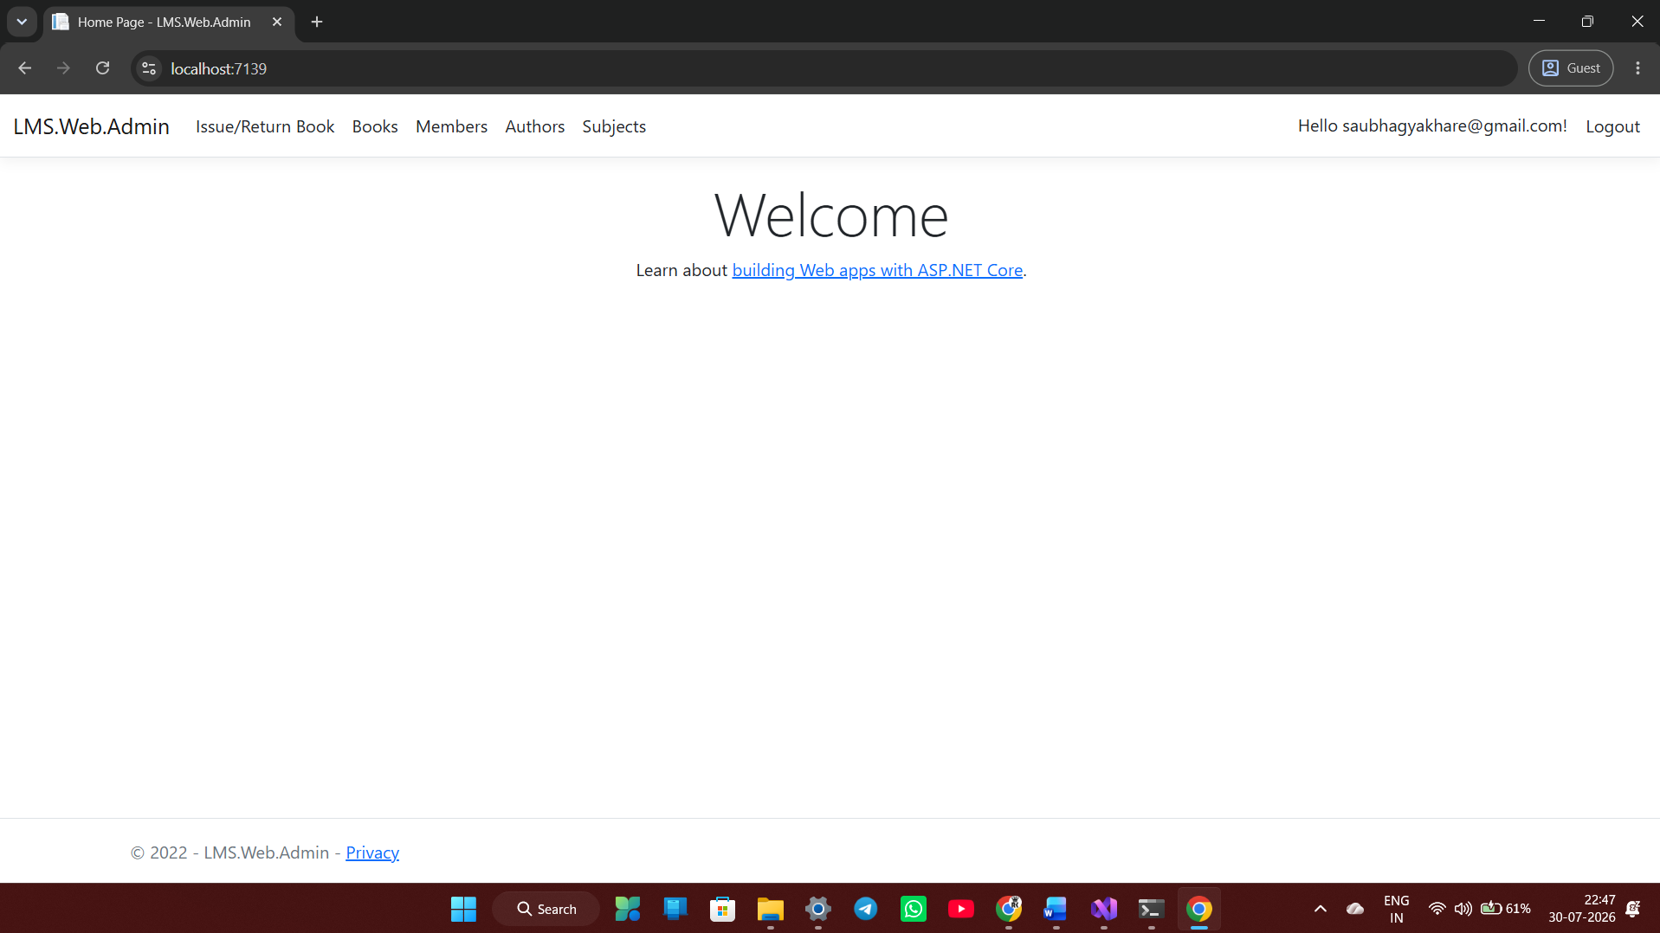

- Manage Books Page
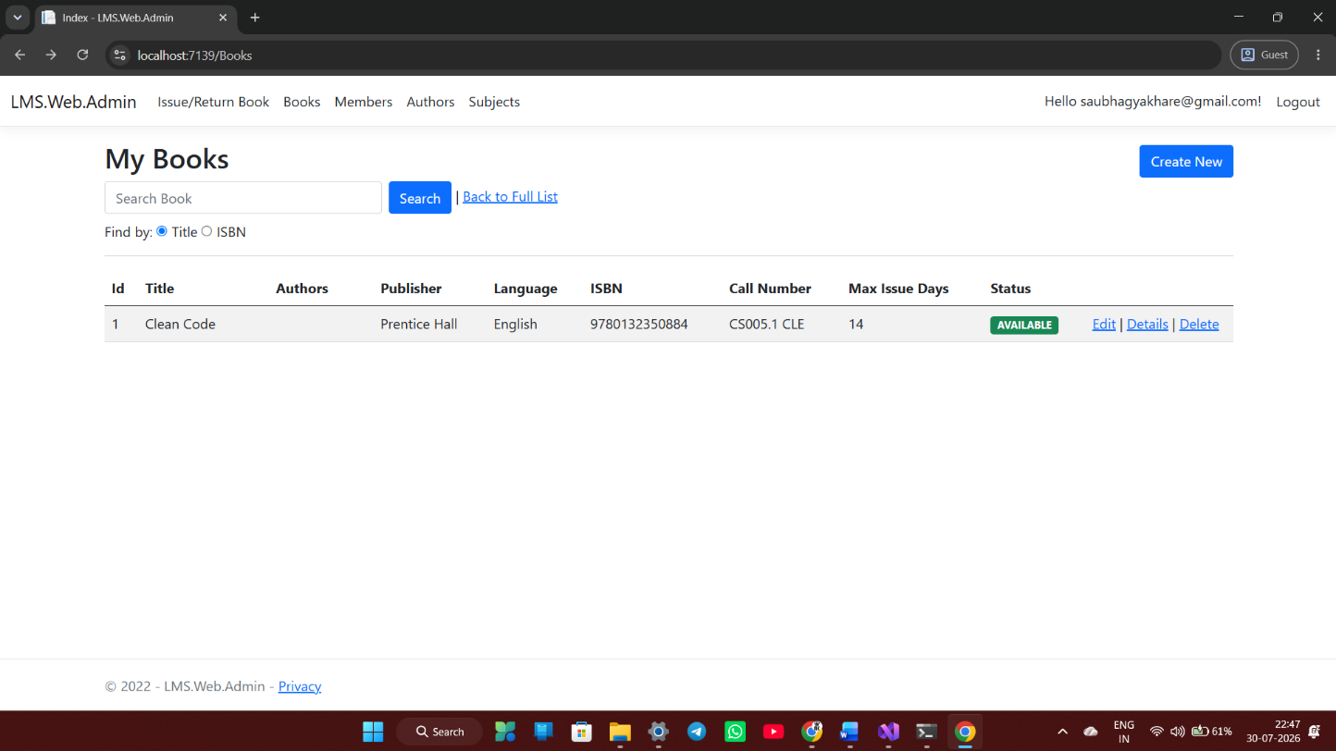
- Add Book Page
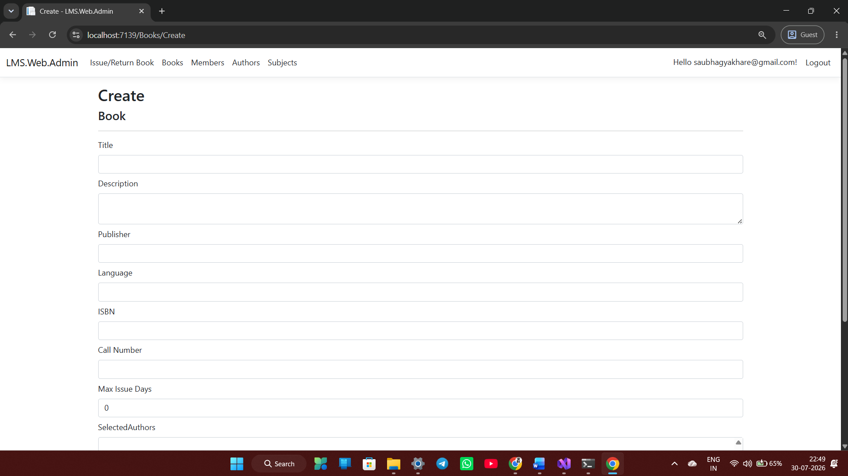

- Issue & Return Book Page
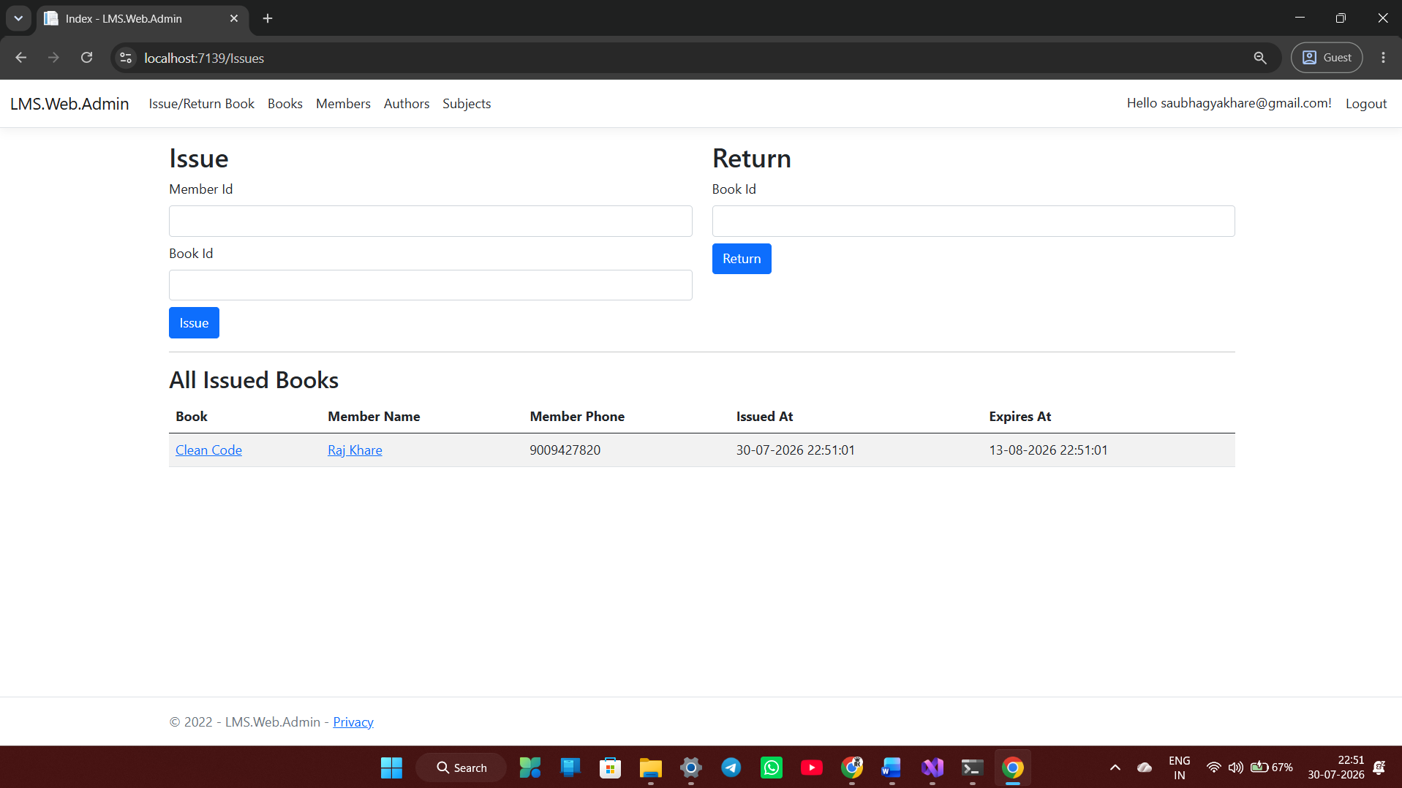
- Members Add Page
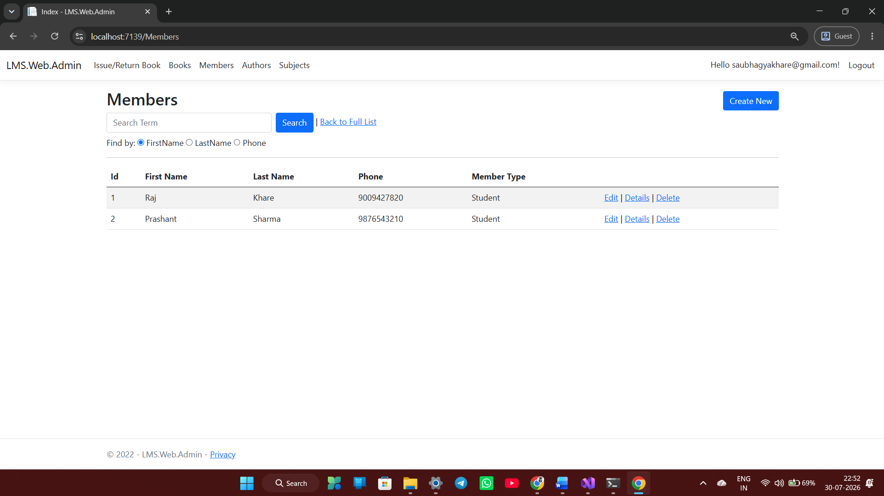
- Subject Add Page
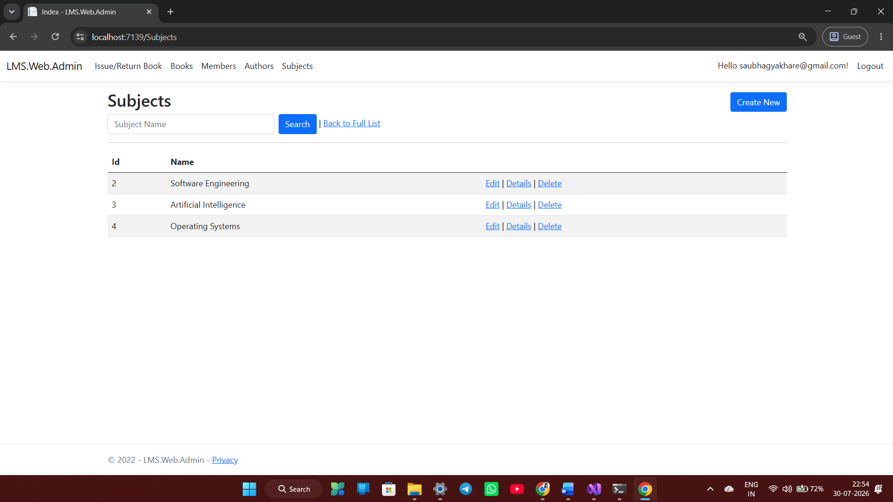
- Authors Add Page
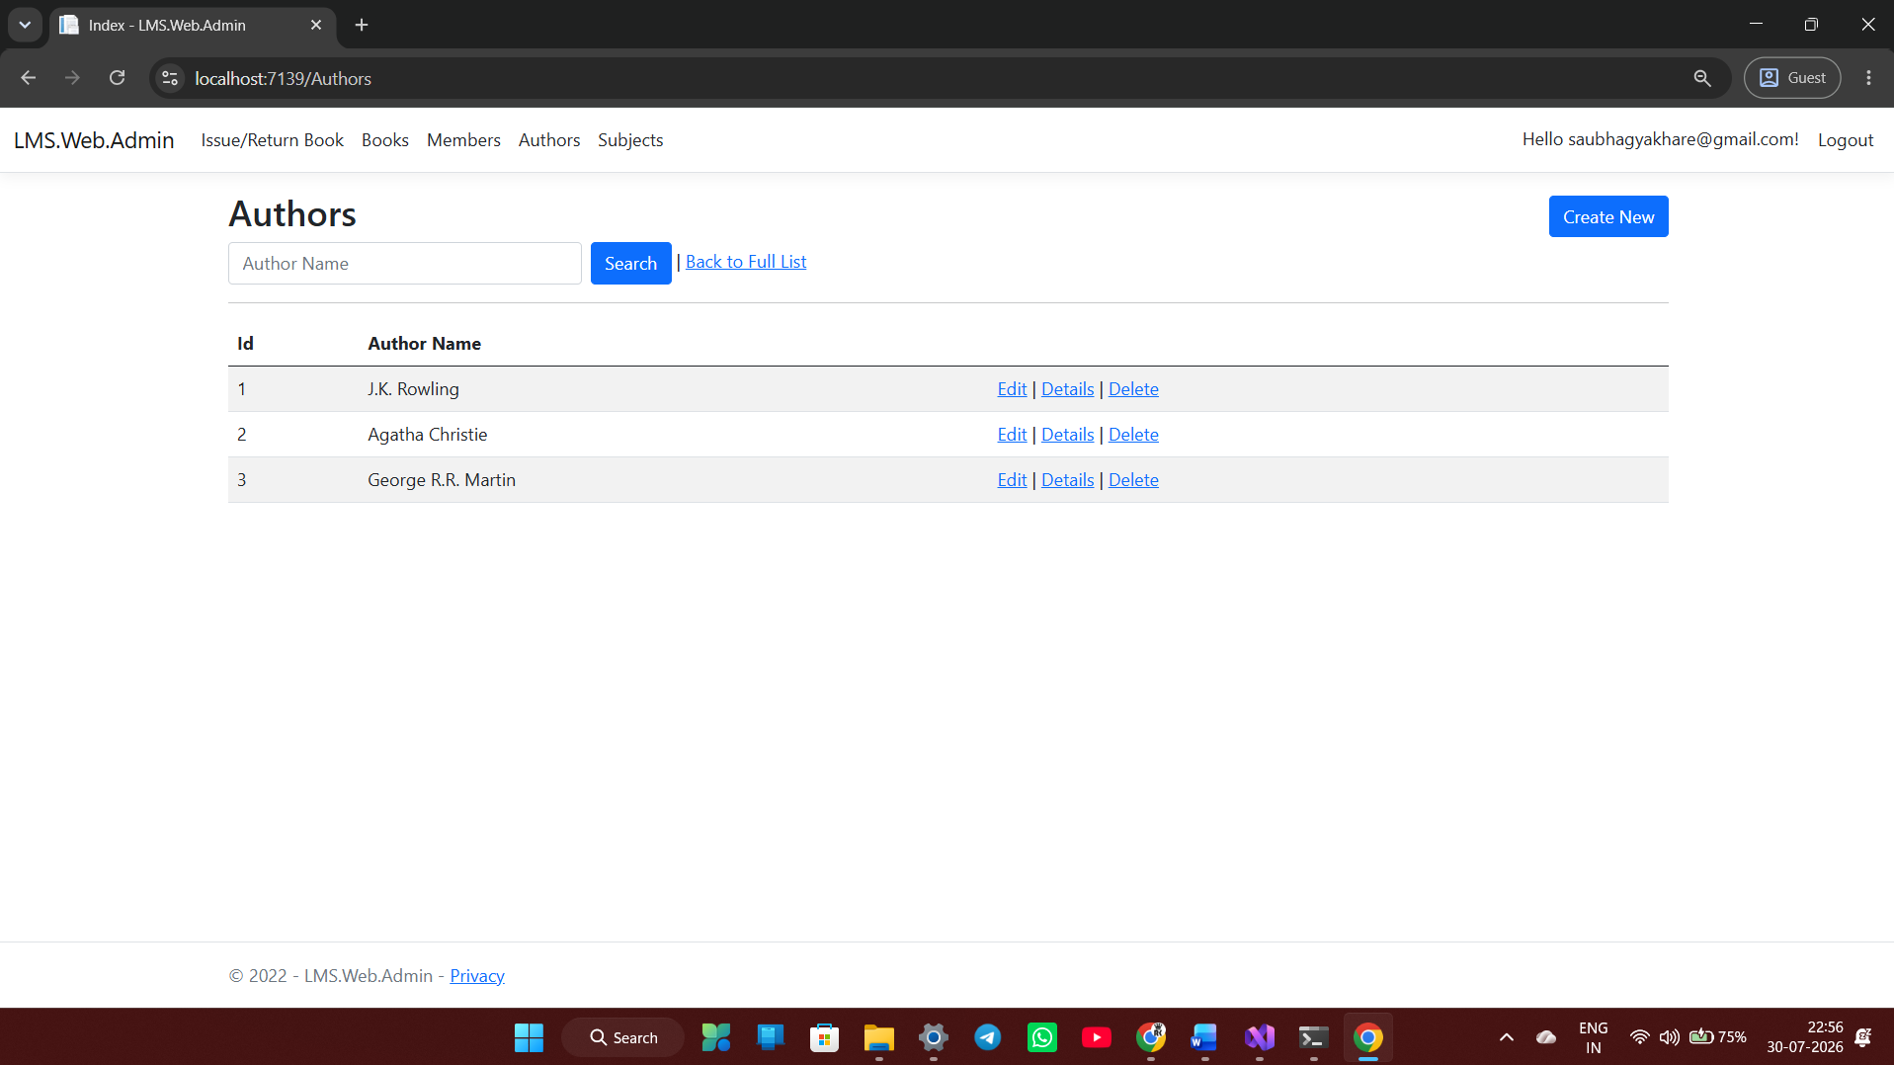

5.2 Future Scope
The system can be further enhanced by adding advanced features such as:
- QR Code and Barcode Integration
- RFID-Based Book Tracking
- Online Book Reservation
- Email and SMS Notifications
- Mobile Application
- Digital Library Integration
- AI-Based Book Recommendation
- Online Fine Payment
- Cloud Database Support
- Multi-Library Management
- Analytics Dashboard
- E-book and PDF Management
Additional security measures such as Two-Factor Authentication (2FA), biometric login, encrypted passwords, audit logs, and role-based permissions can further strengthen the protection of sensitive data and improve system security.
The application can also be upgraded to support multiple libraries or campuses. This feature would allow universities with multiple branches to manage all their library resources through a single centralized application while maintaining separate records for each campus.
Finally, the system can be integrated with institutional portals, learning management systems (LMS), and student information systems. Such integration would create a unified academic ecosystem where students can access learning resources, library services, attendance, and academic information through a single platform.
These improvements will make the system more intelligent, scalable, and suitable for modern libraries.

CONCLUSION
The Library Management System developed using C#, ASP.NET, and Microsoft SQL Server successfully fulfils its objective of automating the day-to-day operations of a library. The system replaces the traditional manual method of maintaining library records with a secure and efficient computerized solution. It reduces paperwork, minimizes human errors, improves data accuracy, and enables quick access to library information.
The application provides a centralized platform for managing books, students, authors, categories, and book issue-return transactions. Administrators can easily perform tasks such as adding, updating, deleting, and searching for books, while students can search for available books, view their borrowing history, and manage their profiles. The automation of routine activities such as issuing books, returning books, and calculating overdue fines helps save time and improves the overall efficiency of library operations.
The project also demonstrates the practical implementation of object-oriented programming, web development, and database management concepts using modern technologies. Features such as secure login, responsive user interface, and efficient database connectivity make the system reliable, user-friendly, and easy to maintain.
The application was tested successfully, and all major modules performed as expected. The modular design of the system allows future enhancements without affecting the existing functionality. Overall, the Library Management System provides an effective, reliable, and scalable solution for educational institutions, helping librarians manage resources efficiently while improving the overall experience for students and library users.

REFERENCES
- Microsoft Documentation – C#
- Microsoft ASP.NET Documentation
- SQL Server Documentation
- Ian Sommerville, Software Engineering, 10th Edition
- Pressman, Software Engineering: A Practitioner's Approach
- Elmasri & Navathe, Fundamentals of Database Systems
- Bootstrap Official Documentation
- HTML5 and CSS3 Documentation
- JavaScript Documentation
- Visual Studio Documentation

